 | 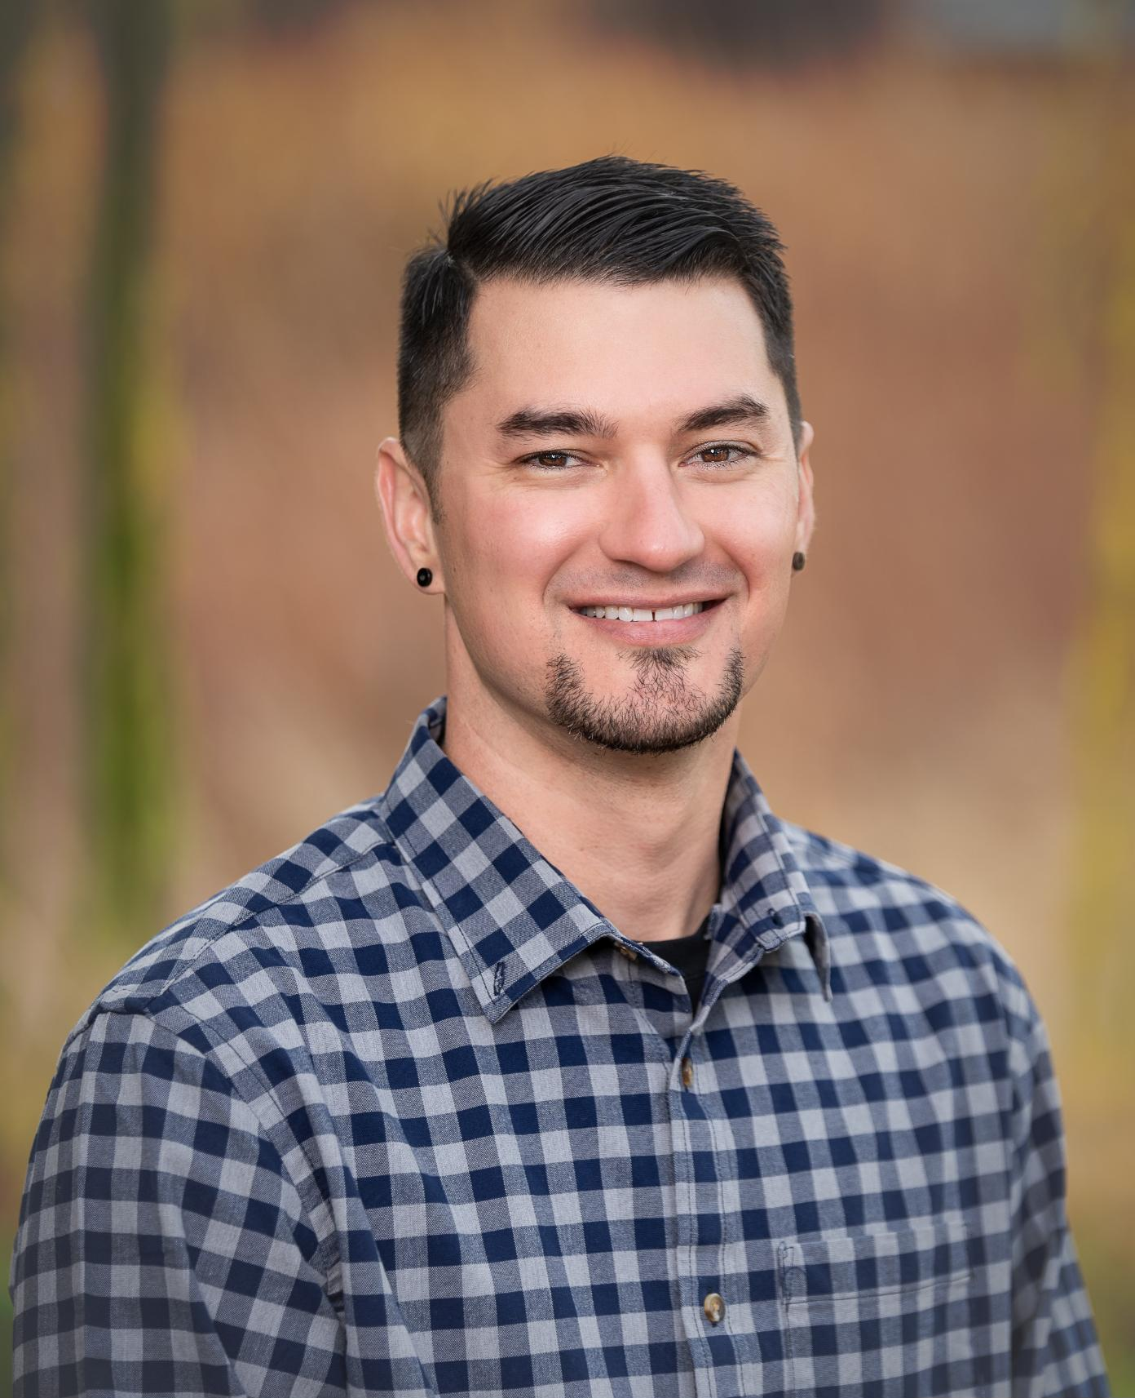 |  |   Nicholas  la mar  Assistant nurse manager  EDUCATION  SAMUEL MERRITT UNIVERSITY  JANUARY 2018 – AUGUST 2019  SUMMA CUM LAUDE GRADUATE  BACHELOR OF SCIENCE IN NURSING  YUBA COLLEGE  JANUARY 2009 - JUNE 2011  HONORS GRADUATE  ASSOCIATES DEGREE IN NURSING  - SACRAMENTO STATE UNIVERSITY  AUGUST 2000 - MAY 2009  UNDERGRADUATE GENERAL EDUCATION  PRE-NURSING MAJOR  CHILD DEVELOPMENT MINOR  HEALTHCARE WORK EXPERIENCE  KAISER PERMANENTE ASSISTANT NURSE MANAGER  JULY 2006 – CURRENT  MEDICAL/ SURGICAL/ TELEMETRY  SOUTH SACRAMENTO, CA  SUTTER HEALTHCARE STAFF RN II  JUNE 2011 – OCTOBER 2014  MEDICAL/ SURGICAL/ TELEMETRY  ROSEVILLE, CA  LICENSURES & CERTIFICATIONS  - CALIFORNIA REGISTERED NURSE  LICENSE #798159  - ADVANCED CARDIOVASCULAR LIFE SUPPORT  EXPIRES JANUARY 2025  - BASIC LIFE SUPPORT  EXPIRES JULY 2023  LEADERSHIP & QUALITY EXPERIENCE  - INTERIM NURSE MANAGER JULY 2022-OCTOBER-2022  - NATIONAL NURSING SUMMIT LEADERSHIP DEVELOPMENT PROGRAM GRADUATE 2022  - ASSISTANT NURSE MANAGER COMMUNITY OF PRACTICE MEMBER  - UNIT PRACTICE COUNCIL MEMBER  - CLINICAL PRECEPTOR FOR SACRAMENTO STATE 2012 - 2021  - KAISER SIMPLY THE BEST AWARD RECIPIENT 2016, 2017, 2018, 2019, 2022  - STAFF NURSE IV 2019 - 2021  - DEPARTMENT QUALITY COUNCIL CHAIRPERSON 2018-2019  - KP NURSE SCHOLARS ACADAMY RN TO BSN GRADUATE

CONTACT INFORMATION
PHONE:
P: (916) 798-8167
W: (916) 539-8019

WEBSITE:
https://nlamar82.wixsite.com/e-portfolio

EMAIL:
P: NLAMAR82@GMAIL.COM
W: NICHOLAS.X.LAMAR@KP.ORG

ADDRESS:
1476 ESTUARY COURT
WEST SACRAMENTO, CA
95691

Summary of qualifications
WORKS AS A NURSE LEADER AND MEMBER OF THE MULTI DISCIPLINARY TEAM WITH 17+ YEARS OF CRITICAL THINKING HEALTHCARE EXPERIENCE TO PROVIDE THE BEST POSSIBLE PATIENT CARE OUTCOMES. PROMOTES AN ENVIRONMENT CONSISTING OF SAFETY, TEAMWORK, COMPASSION AND EFFICENCY WHILE PROVIDING AWARD WINNING CARE.

REFERENCES
KATIE HOGANSON, MSN, RN, MBA
DIRECTOR OF PATIENT CARE SERVICES
KAISER PERMANENTE SOUTH TOWER
(916) 627-7047

MALIA LAVALLE, PhD, CCRN
CLINICAL NURSING EDUCATOR
KAISER PERMANENTE SOUTH SACRAMENTO
(916) 501-4001

